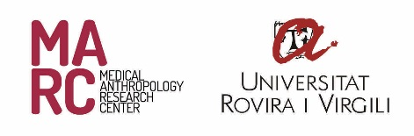
FORM TO PUBLISH RECENT NEWS

This form is used to communicate past, current or upcoming news relevant to MARC members and the general public. Fill in all the relevant sections of this form, download the full version and send it by e-mail to: marc@urv.cat. Be sure to include attachments that are relevant to this document in your email. Thanks.

Títle
Subtitle
Summary
(what; how; who; when; where)
Main Content
(500 words maximum)

Links | Direction [http://exemple.com] | Text for the link
Tags
(example: #research)

Images (50Mb)*  (Up to 3 images) | Attachments
 | ¿Do/es the image/s have link/s? If so, enter them below:?
 | Image Titles: *
Optional: | Which date would you like to publish this news?
*Number the images (ex: image1; image2…)

